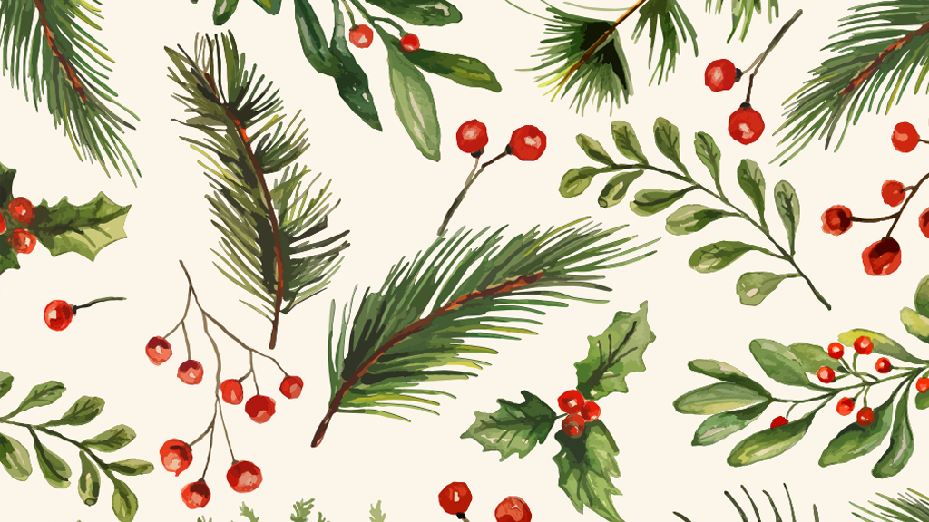
THE Christmas Quiz

- What do people usually put on top of a Christmas tree ?
- a bauble or a light
- a reindeer or an elf
- an angel or a star

- How much does Tesco’s “Finest Christmas Pudding” (800g) cost ?

- £9.00
- £5.00
- £12.00

- In the Chinese calendar, this year is the Year of the …. ?
- Horse
- Dragon
- Snake

- In the Nativity story, what gifts did the three Wise Men bring for baby Jesus ?

- chocolates, tangerines, and marshmallows C
- silver, olive oil, and a golden crown
- gold, frankincense and myrrh

- Which actor is the current Doctor Who on television ?
- Ncuti Gatwa
- David Tennant
- We don’t know – he or she has to regenerate

- Where does Father Christmas (or Santa Claus) live ?
- Scotland
- Lappland
- The North Pole

- Why is the day after Christmas Day called Boxing Day ?
Was it because …
- Traditionally, people would open their Christmas presents on Boxing Day not Christmas Day

- Boxing Day was traditionally a day off for servants – and they would receive a special Christmas box from their masters

- Sporting events used to take place on Boxing Day – football, hunting and boxing … where the name comes from

- What does a child hang up on Christmas Eve ?
- Their Christmas candle
- Their Christmas stocking
- Their Christmas book

- When is the shortest day of the year ?
- 15th December
- 21st December
- 21st June

- In a Christmas pantomime which female character is always played by a man ?

- Buttons
- Aladdin
- The Pantomime Dame

- Who is the most famous character in Charles Dickens’ story, “A Christmas Carol” ?

- David Copperfield
- Ebenezer Scrooge
- Nancy

- How many reindeer pull Father Christmas’ sleigh ?
- One – Rudolph
- Eight - Dasher, Dancer, Prancer, Vixen, Comet, Cupid, Dunder, and Blixem
- Nine – the eight above plus Rudolph !

- In Scotland, people celebrate Hogmanay - on what date is it ?

- 25th December – it’s another name for Christmas Day
- 24th December – it’s celebrated before Christmas
- 31st December – on New Year’s Eve

ANSWERS :
- c
2. a
3. c
4. c
5. c
6. b (British children believe) or c (American children believe),
7. b
8. b
9. b
10. c
11. b
12. c
13. c

