**Reading activity -**

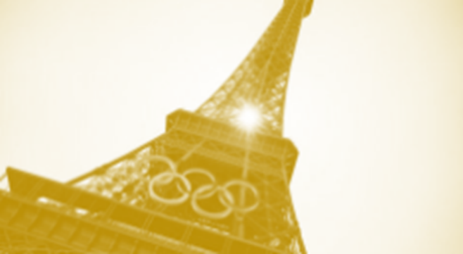**The opening ceremony of the Paris Olympics 2024**

The opening ceremony at the Paris Olympics promises to be a huge event. In a first for the Games, the spectacle will not be in a stadium, but will take place on Paris' famous River Seine.

Here is all you need to know about the ceremony...

It will take place along 6km of the Seine. It will begin at Austerlitz bridge and end among the gardens, fountains and palaces in the shadow of the Eiffel Tower at the Trocadero.

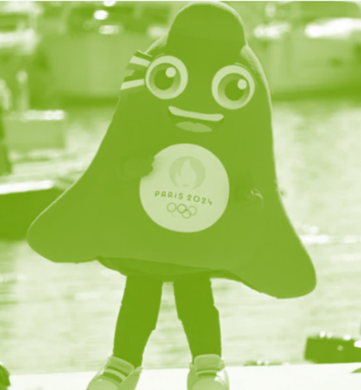There will be almost 100 boats carrying more than 10,000 athletes sailing past Paris' dramatic landmarks, including Notre Dame cathedral and Pont Neuf. The boats will also be used in the artistic part of the ceremony, that will show the history and culture of Paris and France.

The identity of the performers is a secret. Thousands of people are expected to line the river and the streets with millions more watching on television around the world.

"I’d like to show France in all its diversity," said Thomas Jolly, the French actor and theatre director named as the ceremony's artistic director.

The French President, Emmanuel Macron, will open the Games officially, but who will light the Olympic flame? Again, many of the details have been kept as a surprise.

The ceremony begins at 19:30 local time (18:30 BST - British summer time) on Friday, 26th July, and will last just under four hours, with the final stages taking place as the sun sets across the French capital. Thankfully, the Paris weather forecast for Friday evening is good.

Keeping with tradition, Greece will be the first country to be introduced at the ceremony. With NBA star, Giannis Antetokounmpo, carrying a flag for the Games. Next will be the Refugee Olympic Team, while hosts France will be the last to be introduced.

The opening ceremony will be shown live from 17:45 on BBC One.

**New vocabulary**

identity a noun. A person's name and other facts about who they are.

secret a noun. A piece of information that is only known by one person or a few people and should not be told to others.

to line a verb. For example, to stand along the side of something.

diversity a noun. A range of different things or people being included in something.

stage a noun. A part of an activity or a period of development

refugee a noun. A person who has escaped from their own country for political, religious, or because of a war:

**Can you answer these questions?**

1. What is so different about the Olympic opening ceremony in Paris?

……………………………………………………..

1. Where does the ceremony start and finish?

*……………………………………………………..*

1. What or who is being kept secret?

*……………………………………………………..*

1. What does Thomas Jolly, the ceremony’s artistic director, want to show about France most of all?

*……………………………………………………..*

1. The Greek Olympic team will be introduced first at the ceremony, but which team will be introduced second?

*……………………………………………………..*