**Getting ready for a Birthday Party**

**MAKING NOTES - WRITING ACTIVITY**

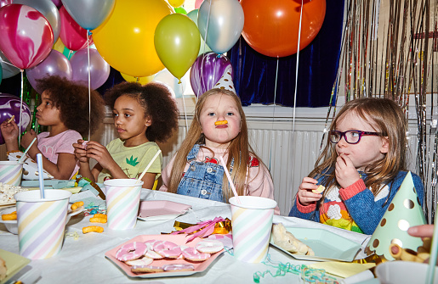

**Read the following text :**

Jan is thinking about what she needs for her daughter’s birthday party…

*“It’s my daughter’s birthday at the end of the month – she’s 5 years old - I can’t believe it ! … I’m going to arrange a party…*

*I need to buy her some invitation cards so she can invite her classmates and friends from her ballet class. I probably need about 30 … No, maybe 40 to be sure.*

*I want some party food – crisps, sausage rolls, jelly mixture etc. My sister, Ellen, wants to make a big cake and I promised to get her the ingredients. She’s given me a list.*

*… and some birthday candles.*

*What next? Oh, some balloons. She’ll like the shiny ones … And some batteries for a stereo to play music.*

*Oh, I forgot ! … I need to remind Paul to book a room at the Activity centre … I hope it’s available still !*

*… and he needs to ask them if they have a high-chair for Danny’s little brother.*

*Do I need to get anything else ? … Oh my goodness !”*

Now, help Jan make a list of things she needs to do :

1. Remind Paul to book a room
2. Get 40 invitation cards
3. Buy party food – crisps, jelly, etc
4. Buy cake ingredients ( Ellen’s list )
5. Get 5 birthday candles
6. Get some shiny balloons
7. Buy batteries for the stereo
8. Ask if the centre has a high-chair…