**READING ACTIVITY**

**Doctor Who**

Doctor Who is a science fiction television series broadcast by the BBC since 1963. The series follows the adventures of a Time Lord called the Doctor, an extraterrestrial being who appears as a human. The Doctor explores the universe in a time-travelling spaceship called the TARDIS.

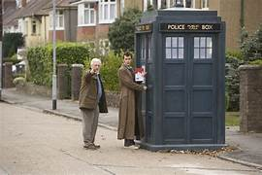To us, the TARDIS appears as a blue British police box but when you step inside it – it is huge.

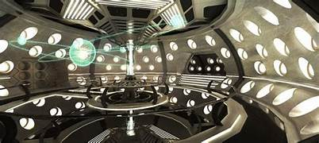

With his different assistants, the Doctor fights enemies, works to save civilisations, and helps people in need.

The Doctor is eccentric. He is not human and has two hearts. He doesn’t understand human relationships like families or that we only have one life ! When the Doctor is unable to heal and cannot escape, he doesn’t die but ‘regenerates’ ! so there have been fourteen Doctors since the first.

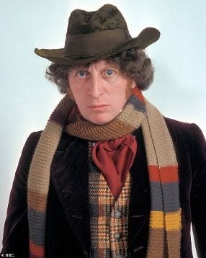All the Doctors have carried a ‘sonic screwdriver’. But each has his or her own style with clothes - maybe wearing a long scarf, a hat, a long coat or a bow-tie… and the first female Doctor wore dungarees, braces and Dr. Marten boots.

Very occasionally, different Doctors meet in stories !

The current Doctor is played by the actor, David Tennant; the current assistant (or companion), Donna, is played by the comedy actress, Catherine Tate.

When David Tennant appeared again as the Doctor everyone was shocked – no Doctor had ever returned.

It is meant for children but whole families sit down to enjoy it. Many adults talk about watching Doctor Who from behind the sofa when they were young ! It has a cult following among some adults too who can tell you everything you need to know and more about the Doctor and his enemies – Davros and the Daleks, the Cybermen, the Weeping Angels – and, of course, Doctor Who’s arch-enemy, the Master.

How well do you know Doctor Who ? Can you answer these questions ?

1. What is special about the TARDIS ?

……………………………………………………………………………...

1. Does extraterrestrial mean …
2. … the Doctor lives underwater ? **OR**

1. … the Doctor doesn’t come from Earth ?
2. Doctor Who has two, humans only have one of these. What is it ?

………………………….

1. Which actor plays the current Doctor Who ?

………………………….

1. What kind of clothes does the Doctor wear ? Name three typical items of clothing :
2. ………………………
3. ………………………
4. ………………………
5. What does regenerate mean ?
6. The Doctor becomes younger. **OR**
7. The Doctor changes into a new human form.
8. The Doctor has to fight many enemies. Can you name three of them ?
9. ………………………
10. ………………………
11. ………………………
12. Who is the Master ?

………………………….

1. Many children watch Doctor Who from behind …
2. … a curtain.
3. … their Dad.
4. … their sofa.